**Array Assignment**

**By Chandrakant Patare**

**1 Wap To Define An Array Of Integer Of Size 6 .Take Input From User And Display It In Reverse Order**

package chandrakant2;

//wap to define an array of integer of size 6 .

//Take input from user and display it in reverse order

import java.util.*;

public class Reversearray {

public static void main(String[] args) {

// TODO Auto-generated method stub

int i[];

i= new int[6];

int a;

Scanner s= new Scanner(System.in);

System.out.println("enter array members");

for( a=0;a<6;a++)

{

i[a]=s.nextInt();

}

System.out.println("entered array members are");

for( a=0;a<6;a++) {

System.out.print(" "+i[a]);

}

System.out.println(" ");

System.out.println("reverse order of array is");

for( a=5;a>=0;a--)

System.out.print(" "+i[a]);

}

}

**OUTPUT:**

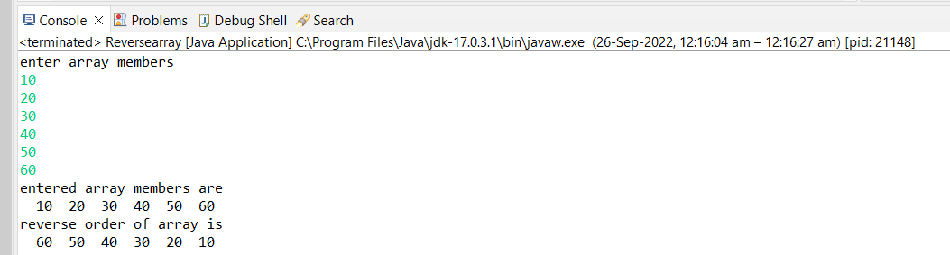

**2 Wap To Ask 5 Names From User And Check If Particular Name Exists In Array Or Not .**

**package** chandrakant2;

//wap to ask 5 names from user and check if particular name exists in array or not .

**import** java.util.*;

**public** **class** Checknames {

**public** **static** **void** main(String[] args) {

// **TODO** Auto-generated method stub

// **TODO** Auto-generated method stub

String i[];

String b[];

b= **new** String[1];

i= **new** String[5];

**int** a;

**int** c=0;

Scanner s= **new** Scanner(System.***in***);

System.***out***.println("enter names");

**for**( a=0;a<5;a++)

{

i[a]=s.nextLine();

}

System.***out***.println("entered names are");

**for**( a=0;a<5;a++) {

{System.***out***.print(" "+i[a]);}

}

System.***out***.println("");

System.***out***.println("enter name to check");

b[0]=s.nextLine();

**for**(a=0;a<5;a++)

{**if**(b[0].equals(i[a]))

{c=1;

**break**;

}

}

**if**(c==1){System.***out***.println("name exist");}

**else**

System.***out***.println("does not exist");

}}

**OUTOUT:**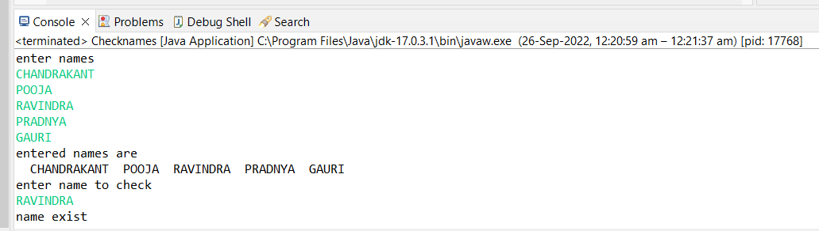

**3 Wap To Define An Array Of Integer And Assign Value In Program And Print Sum Of All Values**

**package** chandrakant2;

//wap to define an array of integer and assign value in program and print sum of all values

**import** java.util.Scanner;

**public** **class** Sumofarray {

**public** **static** **void** main(String[] args) {

// **TODO** Auto-generated method stub

**int** i[]=**new** **int**[6];

**int** a;

Scanner s= **new** Scanner(System.***in***);

System.***out***.println("enter number in array ");

**for** (a=0;a<i.length;a++) {

i[a]=s.nextInt();

}

System.***out***.println("entered array is");

**for** (a=0;a<i.length;a++) {

System.***out***.print(" "+i[a]);

}

System.***out***.println(" ");

**int** sum=0;

**for** (a=0;a<i.length;a++)

{sum=sum+i[a];}

System.***out***.println("the sum of array values is "+sum);

s.close();

}

}

**OUTPUT:**

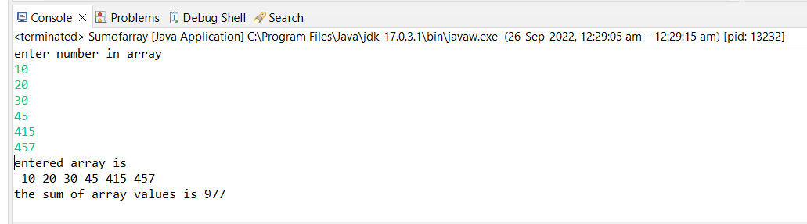

**4 Wap To Print Max And Minimum Value In Given Array**

**package** chandrakant2;

**public** **class** Compare {

**public** **static** **void** main(String[] args) {

// **TODO** Auto-generated method stub

**int** [] arr = **new** **int** [] {85, 11, 95, 75, 56};

//Initialize max with first element of array.

**int** max = arr[0];

//Loop through the array

**for** (**int** i = 0; i < arr.length; i++) {

//Compare elements of array with max

**if**(arr[i] > max)

max = arr[i]

;

}

System.***out***.println("Largest element present in given array: " + max);

max = arr[0];

**for** (**int** i = 0; i < arr.length; i++) {

//Compare elements of array with max

**if**(arr[i] < max)

max = arr[i];

}

System.***out***.println("smallest element is "+max);

}

}

**OUTPUT:**

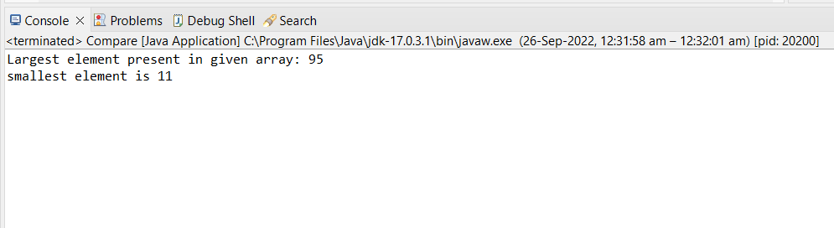

**5 Wap To Find And Print Even Numbers In Given Array**

**package** chandrakant2;

**import** java.util.Scanner;

**public** **class** Printeven {

//wap to find and print even numbers in given array

**public** **static** **void** main(String[] args) {

// **TODO** Auto-generated method stub

**int** i[]= {1,2,3,4,5,6,7,8};

**int** a;

Scanner s= **new** Scanner(System.***in***);

System.***out***.println("array members are");

**for** (a=0;a<i.length;a++)

{

System.***out***.print(" "+i[a]);}

System.***out***.println(" ");

System.***out***.println("Even number in array are ");

**for** (a=0;a<i.length;a++)

{**int** c=i[a];

**if**(c%2==0)

{System.***out***.print(" ");

System.***out***.print(c);

}

}

s.close();

}

}

**OUTPUT:**

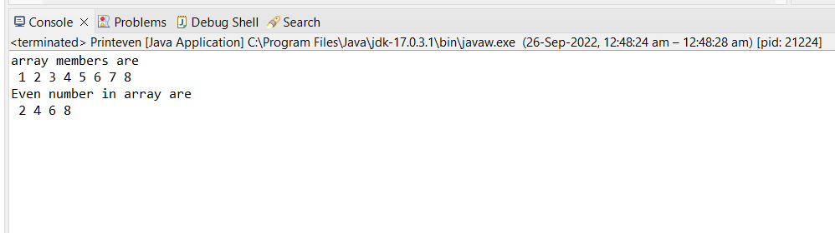

**6 Wap To Find And Print Prime Numbers In Given Array**

**package** chandrakant2;

**import** java.util.Scanner;

//wap to find and print even numbers in given array

**public** **class** Printprime {

**public** **static** **void** main(String[] args) {

// **TODO** Auto-generated method stub

**int** i[]= {19,13,11,22,53};

**int** a;

**int** t=0;

**int** e;

Scanner s= **new** Scanner(System.***in***);

System.***out***.println("array members are");

**for** (a=0;a<i.length;a++)

{

System.***out***.print(" "+i[a]);}

System.***out***.println(" ");

System.***out***.println("Prime number in array are ");

**for**(a=0;a<i.length;a++)

{

t=0;**int** d=i[a];

**for** (e=2;e<((d)-1);e++)

{**if** (d%e==0)

{

t=1;

**break**;

}

}

**if** (t==0)

System.***out***.print(" "+d);

}

s.close();

}

}

**OUTPUT:**

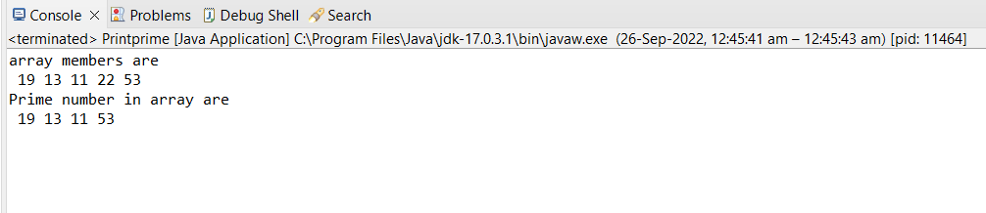

**7 Wap To Search A Particular Number In Given Array And Print Its Position**

**package** chandrakant2;

//wap to search a particular number in given array and print its position

**import** java.util.*;

**public** **class** Printposition {

**public** **static** **void** main(String[] args) {

// **TODO** Auto-generated method stub

**int** i[]= {12,13,14,15,16};

**int** j;

**int** l;

System.***out***.println("array is");

**for** (l=0;l<i.length;l++)

{

System.***out***.print(" "+i[l]);}

System.***out***.println("");

System.***out***.println("enter number");

Scanner s= **new** Scanner(System.***in***);

j=s.nextInt();

**for**(**int** k=0; k<i.length;k++)

**if**(j==i[k])

System.***out***.println("position of number is "+k);

s.close();

}

}

**OUTPUT:**

